**Session report 31/01/2023:**

*LABAUVIE – RAFFAELLI EVA*

*ROB3*

I decided to redesign the shovel parts because they weren’t optimal. I needed to have more “bucket-looking” shovels to scrape the sand better.

I tried to inspire from this wheel :

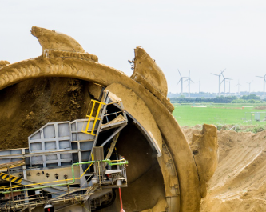

Here is the sketch of how I copied the real bucket from wheel excavator :

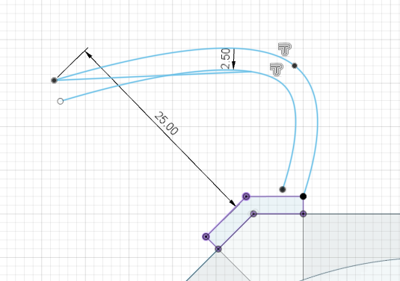

Then I extruded it :

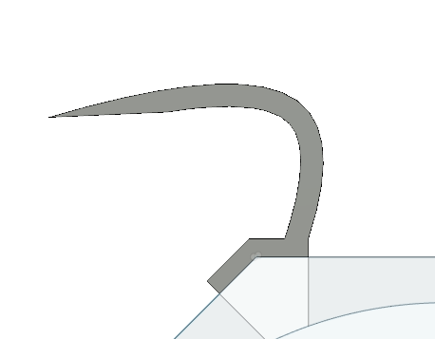

It looks like that from the front.

From the side it looks like that :

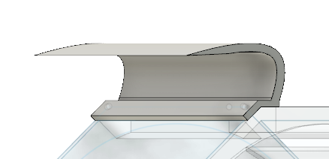

Then I will try to multiply it on the whole wheel to see how it looks.

From the front we have :

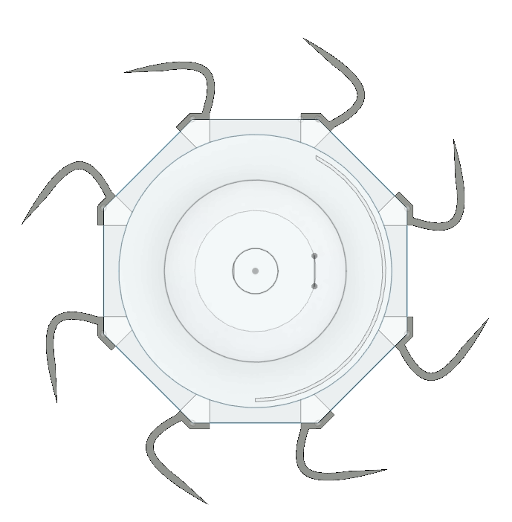

And from the side :

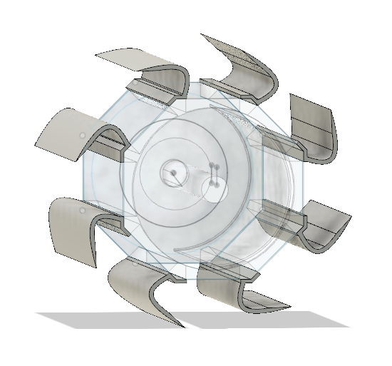

Now I need to make holes on the bases of the buckets to permit attaching it with the wheel later, with a screw.

After a long time trying to get all holes at the same place for every face, I gave up doing it because it is unprecise. I will probably creates the holes manually when I will print the wheel, so I won’t have an issue with the alignement of the wheel face and the bucket one.